# NATIONAL INSTITUTE OF TECHNOLOGY

# ROURKELA



# BIOMEDICAL INSTRUMENTATION ASSIGNMENT

SPHYGMOMANOMETER

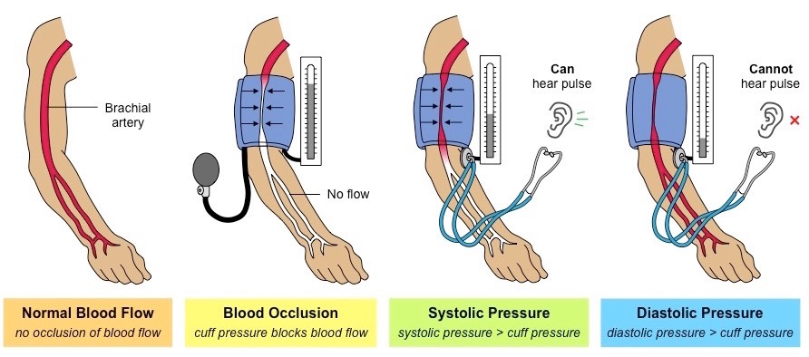

# SHREENANDAN SAHU | 120BM0806

# 2022-23

**Introduction to Bio instruments**

Bioinstrumentation is the use of instruments and devices for the measurement and analysis of biological systems and processes. This field involves the design, development, and application of tools and techniques to measure, record, and analyse biological data, including physiological signals, biochemical parameters, and molecular interactions.

Some examples of bioinstrumentation devices include electrocardiographs (ECG) used to measure heart activity, electromyographs (EMG) used to measure muscle activity, electroencephalographs (EEG) used to measure brain activity, and spectrophotometers used to measure the absorption and transmission of light by molecules.

Bioinstrumentation plays a crucial role in various fields such as medicine, biotechnology, and environmental science. In medicine, bioinstrumentation is used for diagnosis, monitoring, and treatment of diseases. It is also used in drug discovery, clinical trials, and medical device development.

In biotechnology, bioinstrumentation is used for the analysis of biological molecules such as DNA, RNA, and proteins. It is also used in the development of new biotechnologies such as biosensors, microfluidic devices, and lab-on-a-chip systems.

In environmental science, bioinstrumentation is used for monitoring water quality, air quality, and soil health. It helps in the detection of pollutants and contaminants, and in the assessment of the impact of human activities on the environment.

Overall, bioinstrumentation is a rapidly evolving field that continues to drive advances in many areas of science and technology.

**Introduction to Sphygmomanometer**

A sphygmomanometer is a medical device used to measure blood pressure. It typically consists of an inflatable cuff, a pressure gauge, and a mechanism for inflating and deflating the cuff. The term "spigmo" refers to the pulse, as the device measures the pressure of the pulse in the arteries.

**How to use a Sphygmomanometer**

To use a sphygmomanometer, the cuff is wrapped around the upper arm and inflated until it briefly stops blood flow. The pressure is then gradually released, and the gauge is used to measure the pressure of the blood flow as it resumes. This pressure is recorded as two numbers: the systolic pressure (the pressure when the heart beats) and the diastolic pressure (the pressure when the heart is resting between beats). These numbers are expressed in millimetres of mercury (mmHg) and are typically written as a ratio, such as 120/80 mmHg.

**Here are the general steps for using a manual sphygmomanometer:**

* Sit in a chair with your feet flat on the floor and your back supported. Rest your arm on a table or other flat surface with your palm facing up.
* Locate the brachial artery on the inside of your arm, just above the elbow. Place the cuff around your upper arm so that the bottom edge of the cuff is about an inch above the bend of your elbow.
* Close the valve on the rubber bulb and attach it to the cuff. Use the bulb to inflate the cuff until the gauge reads 160-180 mmHg. You should no longer be able to feel your pulse in your wrist.
* Slowly turn the valve counter clockwise to release the pressure in the cuff. Watch the gauge and listen for the first sound of your pulse. This is the systolic pressure. Note the reading on the gauge at this point.
* Continue to release the pressure in the cuff until the sound of your pulse disappears completely. This is the diastolic pressure. Note the reading on the gauge at this point.
* Deflate the cuff completely and remove it from your arm.

Digital sphygmomanometers work similarly, but instead of using a manual bulb and gauge, they use electronic sensors and a display screen to measure and display your blood pressure. The instructions for using a digital sphygmomanometer will vary depending on the specific device, so be sure to read and follow the manufacturer's instructions carefully.

**Normal ranges and variations in BP**

The normal values for blood pressure measured using a sphygmomanometer vary depending on age. Here are the general guidelines for adults:

* Normal blood pressure for adults aged 18 and older is generally considered to be less than 120/80 mmHg.
* Blood pressure between 120/80 mmHg and 139/89 mmHg is considered prehypertension.
* Blood pressure of 140/90 mmHg or higher is considered hypertension (high blood pressure).
* Normal blood pressure: less than 120/80 mmHg
* Elevated blood pressure: systolic between 120-129 mmHg and diastolic less than 80 mmHg
* Stage 1 hypertension: systolic between 130-139 mmHg or diastolic between 80-89 mmHg
* Stage 2 hypertension: systolic at least 140 mmHg or diastolic at least 90 mmHg
* Hypertensive crisis: systolic over 180 mmHg and/or diastolic over 120 mmHg

However, it's important to note that blood pressure can vary from person to person and can be affected by factors such as age, sex, weight, and overall health. Additionally, blood pressure can fluctuate throughout the day in response to physical activity, stress, and other factors. If you have concerns about your blood pressure, you should talk to your healthcare provider for guidance on what is normal for you and how to monitor your blood pressure over time.

**Working Principal of Sphygmomanometer**

The working principle of a sphygmomanometer is based on the measurement of blood pressure in the arteries using a cuff that is inflated and then slowly deflated while the pressure in the cuff is monitored.

The cuff is wrapped around the upper arm and inflated to a pressure higher than the systolic blood pressure. This occludes the brachial artery and the blood flow to the arm is temporarily stopped. The pressure is then slowly released from the cuff and the observer listens for the sounds of blood flow through the artery using a stethoscope or electronically. The first sound that is heard corresponds to the systolic pressure, and the sound disappears when the pressure in the cuff is equal to the diastolic pressure.

The pressure at which the sounds appear and disappear is recorded and expressed as a ratio of systolic to diastolic pressure. This is usually written as two numbers, with the systolic pressure (the pressure in the arteries when the heart beats) listed first and the diastolic pressure (the pressure in the arteries between heartbeats) listed second.

There are different types of sphygmomanometers available, including manual, digital, and ambulatory monitors, each with their own advantages and disadvantages. However, the basic principle of measuring blood pressure using an inflatable cuff remains the same.



*Figure1: showing the working principle of BP machine*

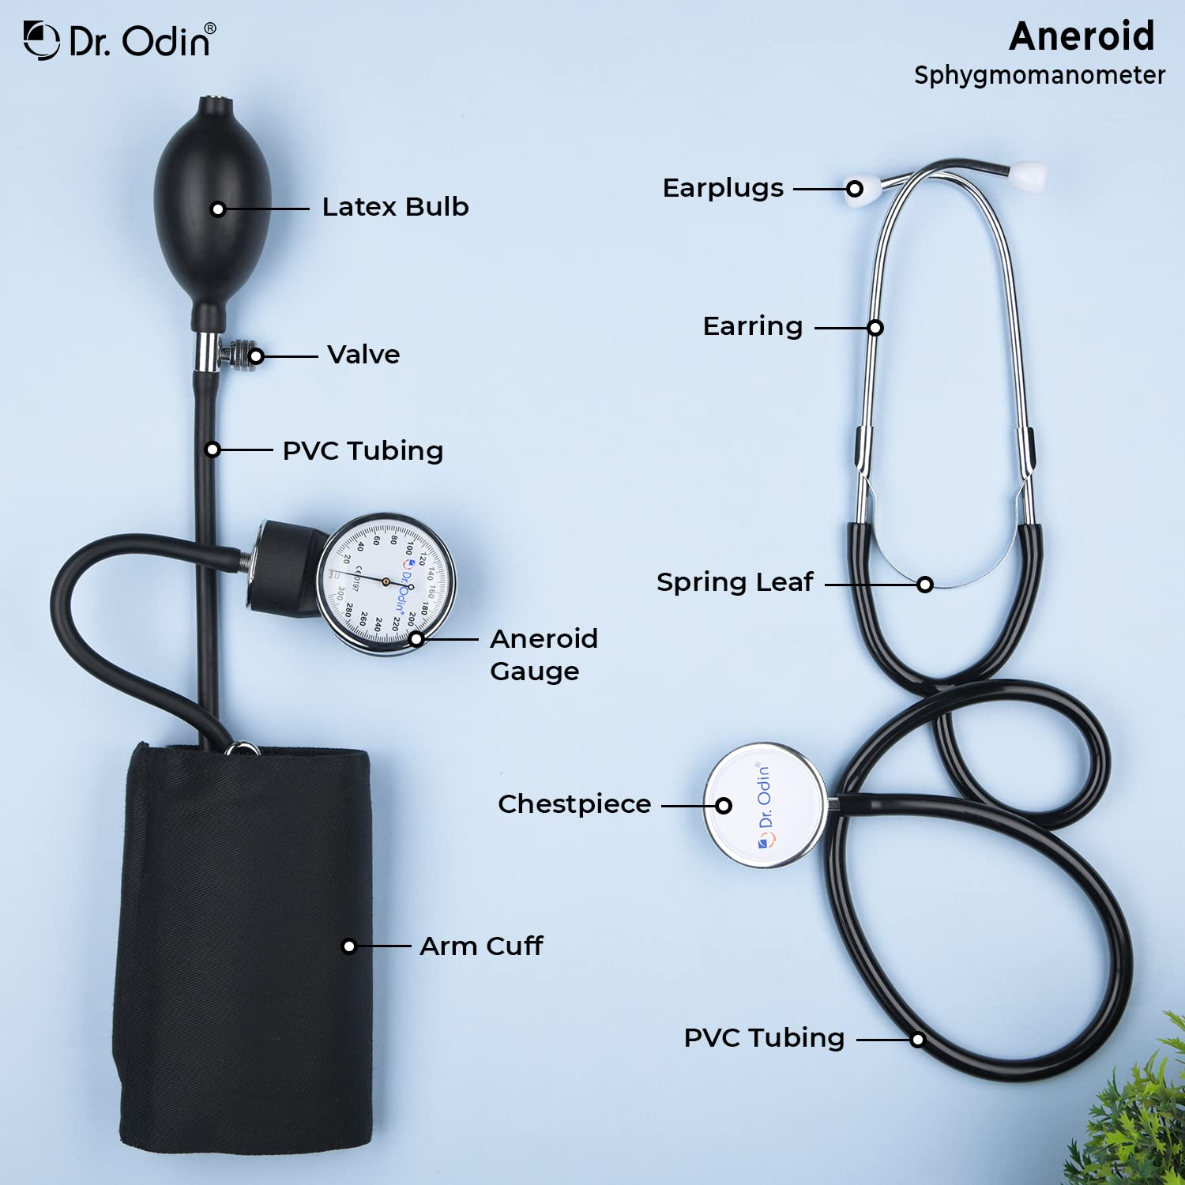

*Figure 2: parts of moder BP measuring machine.*

**Concluding**

In conclusion, a sphygmomanometer is a medical device used to measure blood pressure in the arteries. It works by using an inflatable cuff that is wrapped around the upper arm and inflated to a pressure higher than the systolic blood pressure. The pressure is then slowly released, and the observer listens for the sounds of blood flow through the artery using a stethoscope or electronically. The pressure at which the sounds appear and disappear is recorded and expressed as a ratio of systolic to diastolic pressure. The sphygmomanometer is an essential tool for healthcare providers to diagnose and monitor hypertension, which is a leading cause of heart disease, stroke, and other health problems. Regular monitoring of blood pressure using a sphygmomanometer can help people maintain healthy blood pressure levels and reduce their risk of developing these serious health conditions.

---------------------------------------------

Shreenandan Sahu | 120BM0806